Jmeter Performance Testing Course Works

Contents

1. Week 3 Course Works: Toolbars, Log Into A Website, Regular Expression Extractor 4

# Week 3 Course Works: Toolbars, Log Into A Website, Regular Expression Extractor

* **Using Jmeter Toolbars:** 
  + **Merge:** Open “Clinique Login” Test Plan, merge this test plan with Clinique Search Test Plan.
  + **Revert:** Select Revert to get to the previous Test Plan
  + **Save Selection As**..: Merge again Clinique Loginplan with Clinique Search Test Plan, then save Clinique Search as Clinique Search backup using Save Selection As
  + **Save Node As Image:** Select “Save Node As Image” from Toolbar to save the current Node Image
  + **Save Screen As Image:** Select “Save Screen As Image” from Toolbar to save the current Screen Image
* **Run “Clinique Login” Test Plan with invalid User and Password**
* Search for the HTTP Request that has PASSWORD to log in
* Change the Request Description to “CLINIQUE Login”
* Put the invalid user and password to log in the website
* Run Test Plan. In View Results Tree, use HTML to view Response Data. You should see the message “invalid login”
* **Run “Clinique Login” Test Plan with valid User and Password**
* Put the valid user and password to log in the website
* Run Test Plan. In View Results Tree, use HTML to view Response Data. You should not see the message “invalid login”. You should see the message
* **Open “Clinique Login” Test Plan, run the test to extract a Single String using Regular Expression**
* Run Test Plan, in View Results Tree, using RegExp Tester to test for Regular Expression:
  + name="ORIGINAL_SOURCE" value="(.+?)">
* Under “CLINIQUE Login” HTTP Request, add Regular Expression Extractor to extract value from Login response that match “name="ORIGINAL_SOURCE" value="(.+?)">”

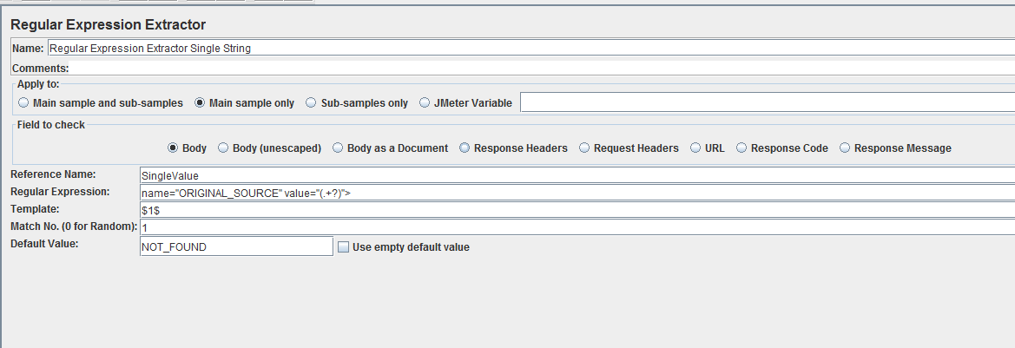

* Under “CLINIQUE Login” HTTP Request, add Debug PostProcessor
* Run Test Plan, write down the result:
  + What is the average response time?
  + What is the min response time?
  + What is the max response time?
  + What is the throughput data of the test?
  + What is the value that matches the Regular Expression?
* In Thread Group, change Number of Threads (users)=3; Ramp-Up=3; Loop Count=2
* Run Test Plan again, write down the result:
  + What is the average response time?
  + What is the min response time?
  + What is the max response time?
  + What is the throughput data of the test?
  + What is the value that matches the Regular Expression?
* **Open “Clinique Login” Test Plan, run the test to extract Multiple Strings using Regular Expression**
* Run Test Plan, in View Results Tree, using RegExp Tester to test for Regular Expression:

name="(.+?)" value="(.+?)">

* Under “CLINIQUE Login” HTTP Request, add Regular Expression Extractor to count how many value from the Login response that match “name="(.+?)" value="(.+?)"> “

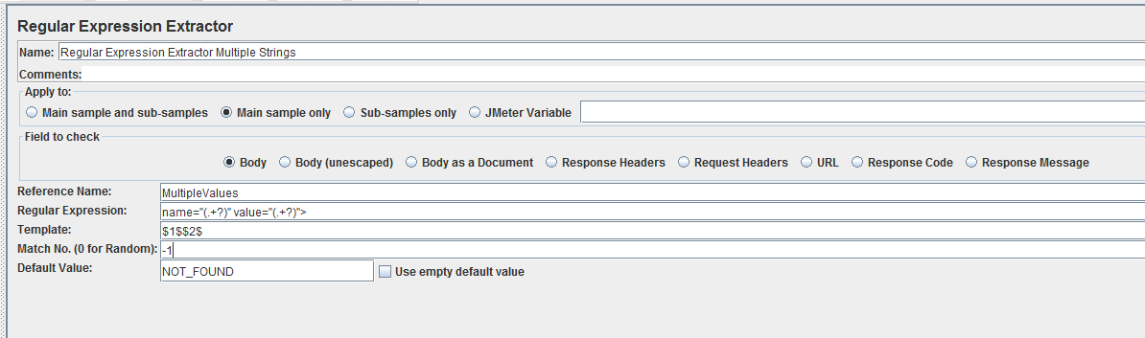

* Under “CLINIQUE Login” HTTP Request, add Debug PostProcessor
* Run Test Plan, write down the result:
  + What is the average response time?
  + What is the min response time?
  + What is the max response time?
  + What is the throughput data of the test?
  + How many value that matches the Regular Expression?
* In Thread Group, change Number of Threads (users)=3; Ramp-Up=3; Loop Count=2
* Run Test Plan again, write down the result:
  + What is the average response time?
  + What is the min response time?
  + What is the max response time?
  + What is the throughput data of the test?
  + How many value that matches the Regular Expression?
* **Homework**: Create a Test Plan called “KIJIJI Login”
* Recording and running a Performance Test for www.clinique.ca website with log in function:

(Pre-condition: an account is needed to create before running this test)

* + Add HTTP(S) Test Script Recorder into WorkBench, then click on Add Suggested Excludes
  + Add HTTP Cookie Manager, HTTP Request Default

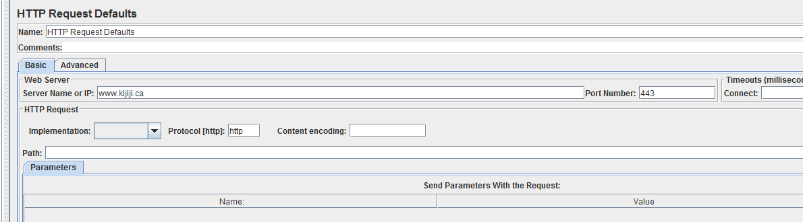

* + Open www.kijiji.ca website
  + Click on “Sign In”, then enter Email Address and Password, then click on “Sign In”
  + Then click on Sign Out
  + Save Test Plan
  + Add Summary Report and View Result Tree from Listeners
  + Run KIJIJI Login Test plan
* Write down the result of the performance test:
  + What is the average response time to run this Test Plan with 5 users in 5 seconds
  + What is the min response time to run this Test Plan with 5 users in 5 seconds
  + What is the max response time to run this Test Plan with 5 users in 5 seconds
  + What is the throughput data of the test?
  + Is there any error occur during the test? If it is, what is the percentage of error?

Paste Screen shot of Summary Report of this test here: